**PEER CRITIQUE FORM**

Please complete this form to document evidence of participating in peer critiques on your project. Once you are done, submit this completed form to the relevant assignment on Canvas.

**Questions in blue should be filled out by the person receiving the critique on their project.** **Questions in red should be filled out by the person giving the critique on that project.**

…

**Your Name:** Gefei Tian

* **Reviewer’s Name:** [Name of person giving feedback]

**Provide a short overview of the purpose of your project (to share with reviewer):** What are the data? What is being visualized? Why are those data being visualized (as opposed to other data)? What message is the project trying to convey?

The data is the covid-19 cases and death data from The New York Times. The purpose of this visualization is to show how fast is covid-19 spreading in the US countrywide and in Massachusetts. As well as showing how different phases in Massachusetts affect the spreading of covid-19.

* **Reviewer’s Response: In its current form, to what extent is this project successful in conveying that intended message? Justify your response.**

[Reviewer’s response]

**Provide a rationale for the visual design of the project:** What kind of visualization was chosen, and why was this kind chosen? What visual encodings (e.g., position, size, color, shape) were chosen for which variables in the data, and why were these encodings chosen? How was the page designed, and why? How does the design of the page complement the design of the visualization, and vice versa?

The first visualization is a stacked bar chart that simply showing the new cases and deaths each day. I hope the graph can show how fast this virus is spreading, and how many lives this virus has taken in a clear way.

The second graph is a heat map showing how many cases each state has. More cases in a state, the brighter the color will be. That can bring the reader’s attention to the state that is not doing so well. The abbreviated legend is not intentional, I just couldn’t figure out how to change it.

The third visualization is a line chart with background color representing different phases in Massachusetts. By combining those two aspects in one graph, we can really see how different phases or actions affect the spreading of covid-19. For example, the growth rate went down a lot after the mask order.

The webpage is a simple one-column design. I was trying to keep it simple and neat. It is mainly divided into three parts, the introduction, the nationwide visualization, and Massachusetts’ visualization. I use a light color background to for my light color visualization. With the text in black color and large sans-serif font, I believe all the text is very clear and easy to read.

**Reviewer’s Response: How effective is the visual design of the project in supporting the intended purpose of the project? Justify your response.**

[Reviewer’s response]

**(ONLY IF APPLICABLE) Provide a rationale for the functionality of the project:** If it is interactive, what forms of interactivity are designed into the project? Why were those forms of interactivity chosen? How does that interactivity enhance the experience of the project?

* **(ONLY IF APPLICABLE) Reviewer’s Response: How effective is the functionality of the project in supporting the intended purpose of the project? Justify your response.**

[Reviewer’s response]

**Describe at least one problem related to the visual design you’d like specific feedback on:**

I would like to know if the size of the visualization works or not. Right now, every visualization is the same size and takes about 60% of the screen width. I feel that large size visualization is can be very attractive and easy to read. However, I do worry about taking too much attention away from the text, and it can looks kind of bold.

* **Reviewer’s Response: Provide feedback on the aspect of visual design described above.**

[Reviewer’s response]

**Describe at least one problem related to the code you’d like specific feedback on:**

I would like to know if my code is clear to read, and how if I should divide more div and sections.

* **Reviewer’s Response: Provide feedback on the aspect of code design described above.**

[Reviewer’s response]

**Describe at least one other problem related to your project you’d like specific feedback on:**

I would like to know if my first visualization looks too simple and if the y-axis scale make sense or not. For the stacked bar chart. I was actually trying to do a side by side bar chart like this (but in a vertical way). However, it is not possible to do this with ggplot. I then used a stacked bar chart with a sqrt transformation y-axis for better visualizable.

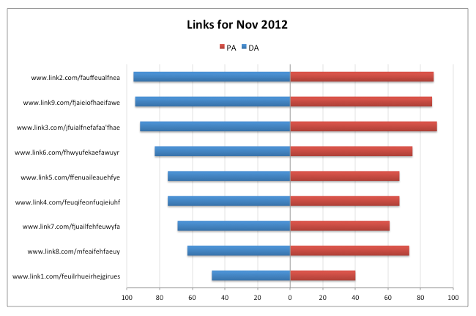

* **Reviewer’s Response: Provide feedback on the issue described above.**

[Reviewer’s response]

* **Reviewer’s summary: Provide a minimum of three recommendations for how to improve the experience and quality of the project you are reviewing. These may be related to visual design, code design, or anything else. For each recommendation, explain why you are making that recommendation, linking it back to the intended message or purpose of the project as a whole.**

[Reviewer’s response]

…

Please use your reviewer’s feedback to consider how to improve your project prior to submission. You are not being asked to implement every recommendation your reviewer provides – instead, you are being asked to consider each recommendation, and whether or not you decide to accept a recommendation, you should have a clear justification for your decision.